Johannes Mduduzi Mahlangu is a seasoned professional with expertise in Supply Chain Management, Project Management, and Business Administration. Holding a Diploma in Business Management from UNISA, he leads Livhu and Musa Enterprise with a focus on efficiency, innovation, and integrity, ensuring successful project execution and sustainable growth.
JOHANNES MDUDUZI MAHLANGU - DIRECTOR
LIVHU AND MUSA ENTERPRISE
Excellence – We are committed to delivering high-quality results with efficiency, innovation, and professionalism.
2
Partnership – We build strong, long-lasting relationships with clients, suppliers, and communities to foster mutual growth.
3
4
Sustainability – We prioritize responsible and sustainable business practices that contribute to economic and social development.
Integrity – We uphold honesty, transparency, and ethical business practices in every tender and project we undertake.
1
OUR CORE VALUES
To establish Livhu and Musa Enterprise as a trusted leader in tendering by securing and delivering high-quality contracts with integrity, efficiency, and innovation. We aim to foster strong partnerships, empower local communities, and drive sustainable economic growth through excellence in procurement and project execution.
OUR GOALS
2014
The company started operating
8
Ongoing Projects with the City of Tshwane
Compliant
SARS
Founding Year: 2014
Founder/CEO: Johannes Mduduzi Mahlangu
Employees: +10
Industry: construction industry, specializing in residential and commercial projects
KEY INFORMATION
LIVHU AND MUSA COMPANY PROFILE
Livhu and Musa Enterprise is a premier construction firm specializing in residential and commercial projects since 2014. Renowned for our commitment to quality, safety, and sustainability, we excel in custom home construction, commercial developments, and green building initiatives. Our strength lies in delivering innovative solutions tailored to clients' unique needs, setting us apart in the industry

EQUIPMENT LIST (Assets)

4x 8 Ton Trucks

3x 1000L/Water Tankers

2x LDV Bakkies

1x Excavator

2 Tipper Trucks

1x TLB

1x Tractor

2 Lowbed Trucks

4x Stump Grinding Machines

3x Graders

20x Brush Cutters

2x Trailers

3 Ride on Machines

5x Chainsaws

4x Pole Pruners

8x Leaves Blowers

OUR SERVICES

CIVIL ENGINEERING [1CE]
GENERAL BUILDING [1GB]
ELECTRICAL ENGINEERIMG[1EP]
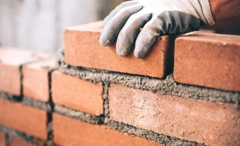



SUPPLY AND DELIVERY
ROAD MARKING[1SK]
LANDSCAPING [1SH]

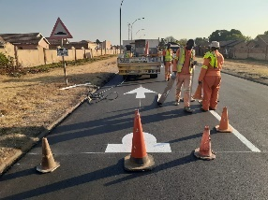


GENERAL CLEANING SERVICES
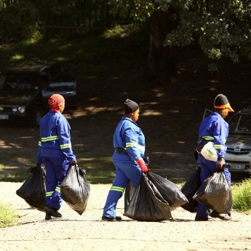

OUR PROJECTS
ROC 20 – 2023/24 (3 Years) – Ongoing

TENDER FOR THE SUPPLY, DELIVERY AND OFF-LOADING OF MANHOLE COVERS TO THE MUNICIPAL STORES INTENDED FOR THE WATER AND SANITATION SERVICES

HHS 10 – 2023/24 (3 Years) – Ongoing

TENDER FOR THE APPOINTMENT OF SERVICE PROVIDERS FOR THE HIRE OF MOBILE DRINKING WATER TANKERS (TRUCKS) WITH THE LOADING CAPACITY OF BETWEEN 10 000 TO 15 000 LITRES OF WATER FOR THE SUPPLY IN THE INFORMAL SETTLEMENTS IN THE CITY OF TSHWANE
05
City Of Tshwane

ES 06 – 2023/24 (3 Years) – Ongoing

TENDER FOR THE SUPPLY AND DELIVERY OF EMERGENCY SERVICES PERSONNEL ROPE RESCUE EQUIPMENT AND ACCESSORIES TO THE CITY OF TSHWANE EMERGENCY SERVICES DEPARTMENT
ES 05 – 2023/24 (3 Years) – Ongoing

TENDER FOR THE SUPPLY AND DELIVERY OF EMERGENCY SERVICES WATER WAYS AND LOGISTICAL EQUIPMENT TO THE CITY OF TSHWANE EMERGENCY DEPARTMENT
ES 03 – 2023/24 (3 Years) – Ongoing

TENDER FOR THE SUPPLY, DELIVERY AND OFFLOADING OF HAZMAT EQUIPMENT TO THE CITY OF TSHWANE EMERGENCY SERVICES DEPARTMENT
EED 05 – 2023/24 (3 Years) - Ongoing

TENDER FOR THE SUPPLY, DELIVERY AND OFF-LOADING OF ELECTRICAL CABLES, WIRE AND CONDUCTORS UTILISED BY THE CITY OF TSHWANE
08
City Of Tshwane

07
City Of Tshwane

06
City Of Tshwane

04
City Of Tshwane

03
City Of Tshwane

02
City Of Tshwane

City Of Tshwane
SS 02 – 2023/24 (3 Years) - Ongoing

TENDER FOR THE CORPORATE HIRE OF GENERAL CONSTRUCTION MACHINES AND CONSTRUCTION EQUIPMENT

SS 01 – 2023/24 (3 Years) - Ongoing

TENDER FOR THE CORPORATE HIRE OF GENERAL CONSTRUCTION VEHICLES AND REFUSE REMOVAL VEHICLES FOR THE CITY OF TSHWANE

CONTACT DETAILS

VISIT US

3138B CRANE STREET
THATCHFIELD HILLS
RUA-VISTA X 13
CENTURION
GAUTENG
0157

PHONE

012 880 1893

EMAIL

INFO@LIVHUANDMUSA.CO.ZA

